Predicting Adolescent Sadness Using Machine-Learning Models and YRBSS Data
Michael Kamp
College of Arts and Sciences, Davenport University
DATA 747: Python for Data Analytics
Instructor: Michael Pomatto
December 4, 2025

Abstract

This project examined whether demographic, behavioral, and health-related variables from the 2019 Youth Risk Behavior Surveillance System (YRBSS) could be used to predict persistent sadness or hopelessness among U.S. high school students. After cleaning and preparing the dataset, two supervised machine-learning models—logistic regression and a decision-tree classifier—were developed and evaluated. Exploratory analysis highlighted several behavioral and demographic patterns associated with reported sadness, including physical inactivity, BMI percentile, and certain substance-use behaviors. Model performance varied considerably: logistic regression demonstrated limited predictive ability, while the decision tree achieved high overall accuracy but struggled to identify the minority class of students reporting persistent sadness. These findings suggest that additional predictors, class-imbalance techniques, or more advanced modeling approaches may be necessary to improve minority-class detection. The study contributes to ongoing efforts to understand adolescent mental-health risk factors and highlights the challenges of predicting complex emotional outcomes using cross-sectional survey data.

Keywords: adolescent mental health, machine learning, YRBSS, logistic regression, decision tree, classification

Introduction
Adolescent mental health continues to be a significant public health concern in the United States. National survey data show rising rates of depression, anxiety, and persistent sadness among high school students. The Youth Risk Behavior Surveillance System (YRBSS), administered by the Centers for Disease Control and Prevention (CDC), provides comprehensive data for examining behavioral, demographic, and psychological factors that influence adolescent well-being.
The present analysis focuses specifically on question QN8, which asks whether a student felt sad or hopeless almost every day for at least two consecutive weeks during the past year. This measure is commonly associated with depressive symptoms and reflects an elevated risk for mental-health challenges. Understanding the behavioral and demographic patterns linked with QN8 is essential for guiding prevention strategies, supporting early intervention, and helping schools and communities allocate mental-health resources effectively.
Machine learning (ML) techniques offer opportunities to explore these associations at scale. By applying supervised classification models, this project evaluates whether behavioral indicators, health-related behaviors, and demographic characteristics can predict self-reported sadness or hopelessness. Although the goal is not clinical diagnosis, the findings may assist in identifying student groups at heightened risk and informing future research on adolescent mental-health screening and support.

Business Understanding
The purpose of this project is to determine whether machine learning models can reliably predict persistent sadness or hopelessness (QN8) based on behavioral, demographic, and health variables in the 2019 Youth Risk Behavior Surveillance System (YRBSS; Centers for Disease Control and Prevention [CDC], 2020) dataset. From both a public health and practical decision-making perspective, accurate prediction could support early identification of students who may need assistance, help schools design targeted mental-health programs, inform policy decisions related to youth well-being, and highlight which behaviors or demographic factors are most strongly associated with emotional distress.
This project follows a standard data-science workflow consisting of data understanding, data preparation, exploratory analysis, modeling, and evaluation. This workflow also mirrors the structure of the accompanying Jupyter notebook.
Primary Research Question
Can demographic, behavioral, and health-related variables from the CDC YRBSS dataset be used to accurately predict whether a student has experienced persistent sadness or hopelessness (QN8)?
Supporting Objectives
- Identify which predictors (e.g., BMI percentile, physical activity, substance use, grade level, race/ethnicity) are most strongly associated with QN8.
- Compare the performance of two classification models: logistic regression and a decision tree classifier.
- Evaluate model effectiveness using confusion matrices, ROC curves, AUC scores, and feature-importance rankings.
- Determine whether the models demonstrate meaningful predictive value or whether the relationships are too weak to support reliable classification.

Data Understanding
The dataset used in this project is the 2019 Youth Risk Behavior Surveillance System (YRBSS; Centers for Disease Control and Prevention [CDC], 2020). The YRBSS collects nationally representative information on health-related behaviors among U.S. high school students in grades 9–12. These behaviors include mental-health indicators, injury and violence, substance use, dietary patterns, and physical activity.
The raw 2019 dataset is provided as a fixed-width (.dat) file, accompanied by CDC-supplied SAS INPUT scripts that define each variable’s name, starting position, and width. In this project, these layout definitions were used to construct a custom parser in Python, enabling accurate import using the pandas.read_fwf() function.
After parsing, the dataset contained 13,677 records and 134 variables. These variables include demographic indicators, mental-health measures, physical activity and dietary behaviors, experiences with violence and bullying, and BMI-related metrics.
Missing values were encoded using CDC conventions (7 = refused, 8 = missing, 9 = not applicable) and were converted to NaN to ensure accurate statistical analysis and preprocessing.
Overall, the dataset provides a rich foundation for predictive modeling, with QN8 serving as the target variable for all subsequent analyses.
Data Preparation
The data preparation stage ensured that the dataset was cleaned, standardized, and ready for machine-learning analysis. CDC-coded missing values were converted to NaN, and incomplete records were removed, reducing the dataset to 5,760 complete observations.
Categorical variables were transformed using one-hot encoding, and numerical predictors were standardized using z-score scaling via the StandardScaler function to ensure consistent variable scaling across the model inputs.
Finally, a stratified train–test split was applied to preserve the distribution of mental-health outcomes, resulting in 4,320 training observations and 1,440 testing observations.
Exploratory Data Analysis
Exploratory Data Analysis (EDA) examined demographic distributions, behavioral indicators, and numerical relationships within the dataset. Visualizations included frequency plots for grade level, sex, and race/ethnicity; behavioral patterns such as vaping, cigarette use, and soda intake; and a correlation heatmap for numerical variables. These analyses helped identify potential predictors and provided insight into variable distributions relevant to model performance.
Note. Detailed exploratory visualizations, including demographic distributions, behavioral indicators, and a correlation heatmap, are presented in the accompanying Jupyter notebook. These graphics support the data understanding process but are not included in this report in accordance with APA formatting guidelines.

Modeling
Two classification models were applied: logistic regression and a decision-tree classifier. Logistic regression served as an interpretable baseline model, while the decision tree captured nonlinear relationships and interaction effects among predictors. Both models were trained on the prepared dataset and evaluated using accuracy, precision, recall, F1-scores, ROC curves, and AUC values. Performance on the minority class was of particular importance due to the strong class imbalance in the outcome variable.
Results
Model performance was evaluated using multiple classification metrics. Because only a small proportion of students reported persistent sadness (QN8 = 1), special attention was given to how effectively each model identified the minority class.
The logistic regression model demonstrated limited predictive ability, achieving an accuracy of 0.141 and an AUC of 0.534. Precision for class 0 was high (0.95), but recall was low (0.10), indicating that the model failed to correctly identify most students who did not report sadness. For class 1, precision was 0.05 and recall was 0.89, meaning the model frequently misclassified non-sad students as sad or hopeless. The confusion matrix for logistic regression is presented in Figure 1.
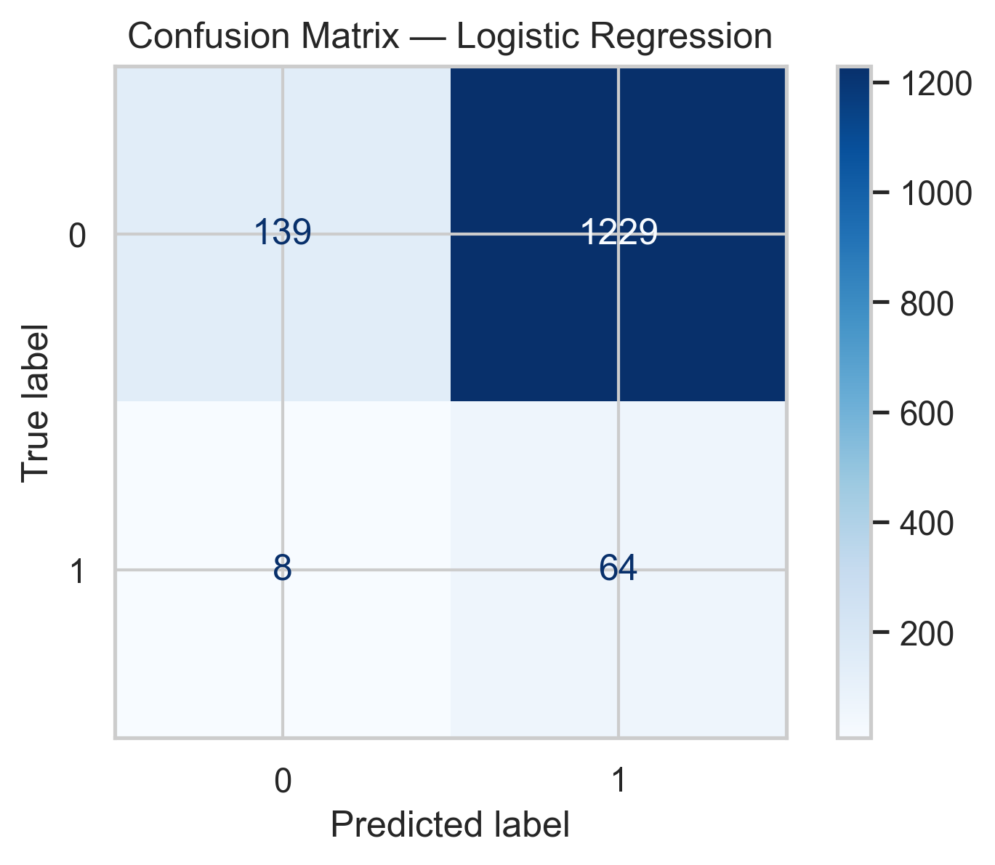
Figure 1
Confusion Matrix — Logistic Regression
The decision-tree classifier achieved substantially higher overall accuracy (0.917). However, its performance on the minority class remained limited, with precision of 0.16 and recall of 0.15. The model correctly classified most non-sad students but struggled to identify those reporting persistent sadness. The decision-tree confusion matrix is shown in Figure 2.
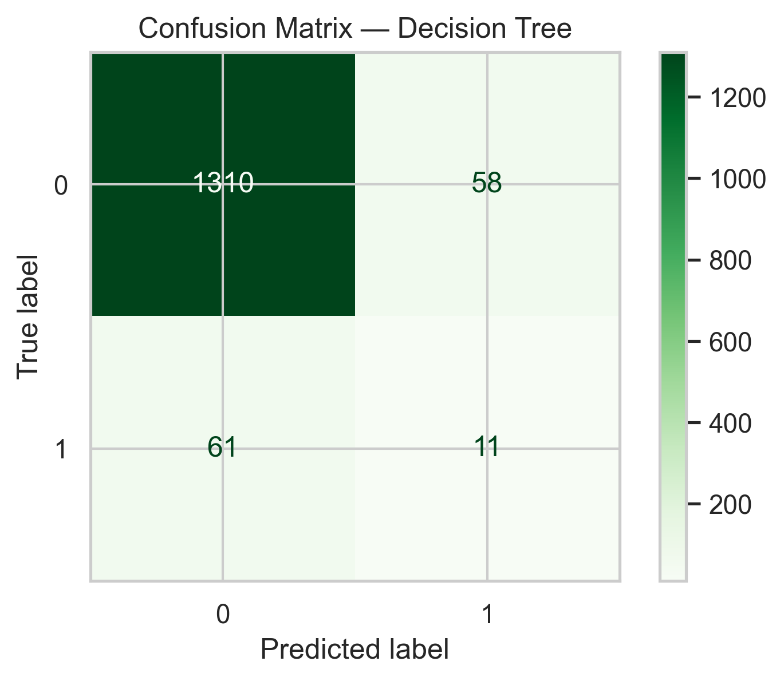
Figure 2
Confusion Matrix — Decision Tree
ROC curves for both models are shown in Figure 3. Neither model achieved strong discriminative performance, with logistic regression producing an AUC of 0.534 and the decision tree an AUC of 0.559. Both curves remained close to the diagonal reference line, indicating limited ability to distinguish between the two outcome classes.

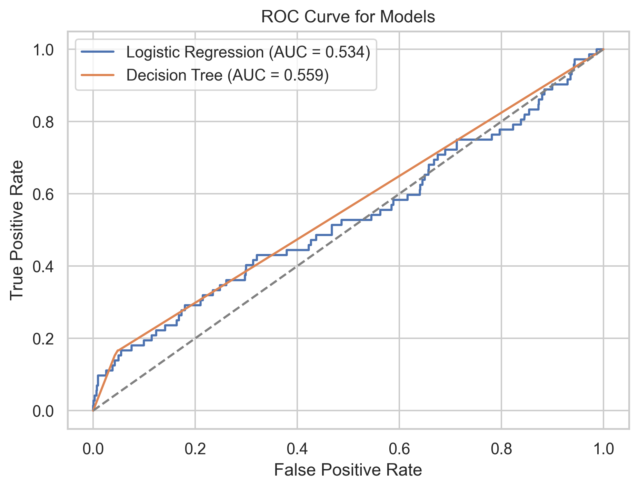
Figure 3
ROC Curve for Logistic Regression and Decision Tree
Feature-importance scores from the decision-tree classifier identified several predictors as influential. Variables such as physical inactivity, BMI percentile, soda consumption, and cigarette or e-cigarette use contributed most strongly to model decision-making. These results are displayed in Figure 4.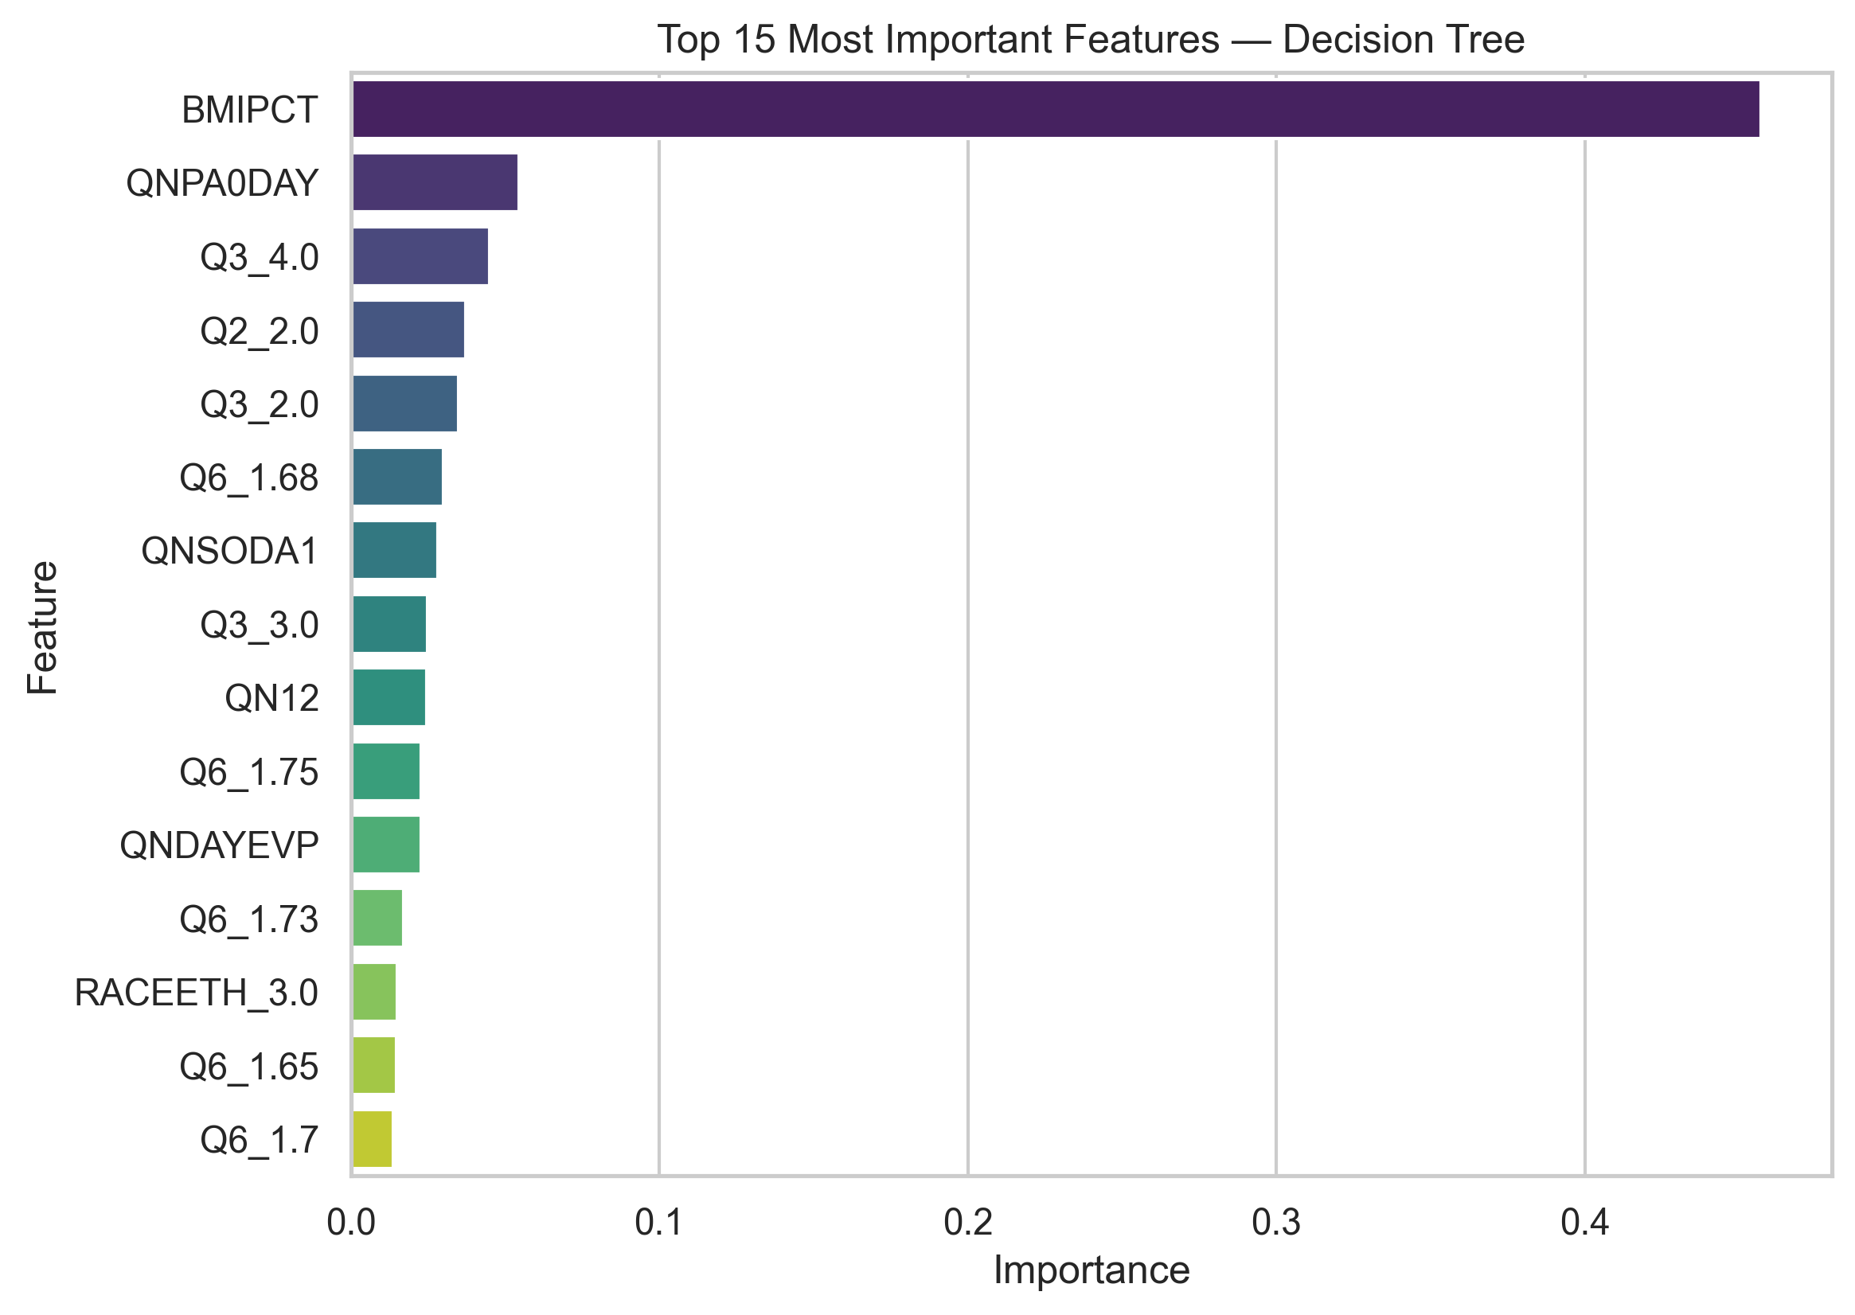Figure 4
Top 15 Most Important Features — Decision Tree

Conclusion
This project evaluated whether demographic, behavioral, and health-related variables from the 2019 YRBSS dataset could be used to predict persistent sadness or hopelessness among high school students. Although the models identified several meaningful predictors, overall classification performance—particularly for the minority class—was limited. Logistic regression showed minimal discriminative ability, and while the decision-tree classifier achieved high overall accuracy, it struggled to correctly identify students who reported persistent sadness. These findings suggest that the underlying relationships between the available predictors and mental-health outcomes are complex and may not be easily captured using simple classification models.
Despite these limitations, the analysis revealed several behavioral and demographic factors consistently associated with sadness indicators, including physical inactivity, BMI percentile, soda consumption, and tobacco or e-cigarette use. These variables may warrant further investigation in school-based mental-health screening or prevention programs. The results also underscore the importance of addressing substantial class imbalance when modeling rare mental-health outcomes.
Future work should explore advanced techniques such as oversampling (e.g., SMOTE), cost-sensitive learning, or ensemble methods that may improve minority-class detection. Incorporating additional contextual variables—such as school climate, social support, or longitudinal data—may further strengthen predictive performance. Continued refinement of these models could support early identification of at-risk students and contribute to more effective mental-health interventions in adolescent populations.
References
Centers for Disease Control and Prevention. (2020). Youth Risk Behavior Surveillance System (YRBSS) 2019 data. https://www.cdc.gov/healthyyouth/data/yrbs/data.htm
Pedregosa, F., Varoquaux, G., Gramfort, A., Michel, V., Thirion, B., Grisel, O., Blondel, M., Prettenhofer, P., Weiss, R., Dubourg, V., Vanderplas, J., Passos, A., Cournapeau, D., Brucher, M., Perrot, M., & Duchesnay, É. (2011). Scikit-learn: Machine learning in Python. Journal of Machine Learning Research, 12, 2825–2830.
Hunter, J. D. (2007). Matplotlib: A 2D graphics environment. Computing in Science & Engineering, 9(3), 90–95.
McKinney, W. (2010). Data structures for statistical computing in Python. In Proceedings of the 9th Python in Science Conference (pp. 51–56).

